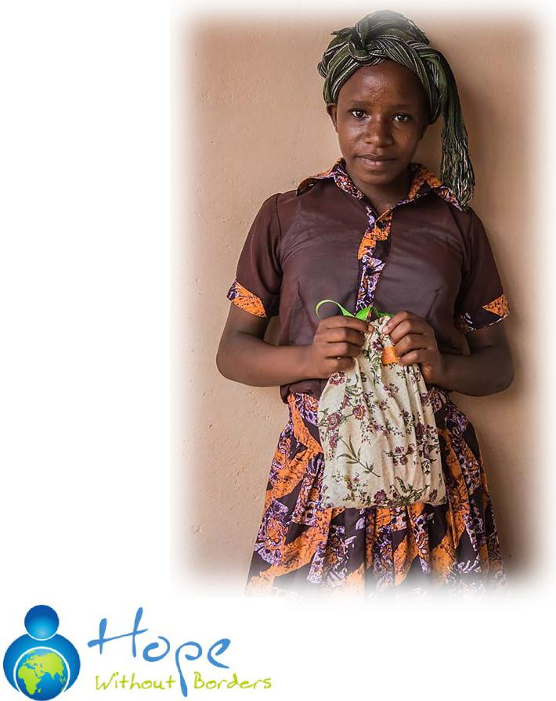
THE RED ELEPHANT PROJECT
There are girls who dream about becoming doctors, teachers, journalist and lawyers. With empty stomachs, these girls travel to school through dangerous corridors in the early morning hours. Arriving early, they study by the light of a single window in hopes of moving on to the next grade. Then one day, they start their period and everything changes. Their parents can’t afford food, much less sanitary pads. These girls search for old clothes, newspapers, workbook pages and banana leaves in desperation to stop the flow long enough to attend classes. Without resources, they can no longer stop the monthly flow and they must drop out of school. So, dreams are lost and the cycle of poverty continues.
The Problem: Every year thousands of girls drop out of schools in the slums and rural villages because they started their period and they can't afford sanitary pads on their parent's meager income. In the Nairobi slums, up to 60% of girls drop out of school several months after their period starts. Needless to say, not being able to obtain an education leads to unfinished dreams, undiscovered leaders and continued poverty.
The Solution: Hope Without Borders started The Red Elephant Project in 2014 and has been able to keep more than 4000 girls in school to pursue their dreams, but we need your help. There are hundreds more waiting and the requests are piling up.
For as little as $10, we can distribute one reusable sanitary pack to keep a girl in school for 2-3 years. Our local volunteers distribute these packs along with encouragement and education about their changing bodies.
Young girls are not the only ones who suffer. We have discovered in our travels women who must remain in their homes during their menstruation, resulting in loss of income as well as dignity and freedom. Freedom to pursue their dreams 365 days a year. Freedom to provide for their families.
How You Can Help
You can visit us on Facebook or our website at:
www.hwb-int.org
Please help us today! These girls are depending on you.

How you can help:
We need the following donations
- 100% cotton prints (no military, animals or people)
- 100% cotton flannel (no military, animals or people)
- 100% cotton girls underwear sizes 10,12, 14 and 16. Must be new, not white and briefs or hipsters. No Disney, animals or people.
- 100% cotton washcloths- no white, prefer dark colors
With monetary donations we can purchase these packs from organizations in the USA or from our sewing co-op in Kenya. Each pack is about $10. You can donate securely on our website at: www.hwb-intl.org and put “Red Elephant Project” in the “comment” section.
We also have sewing parties, so watch our event page on our website or our facebook page.
We are a registered 501 ©3 and your donations can be tax deductible.
For more information please contact Julie Parve at Julie.parve@hwb-intl.org
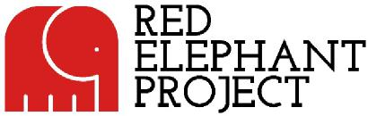
We have distributed packs in:
Kenya
Tanzania
Uganda
Ghana
Nicaragua

